


Faculty of nursing Medical Surgical Nursing Medical Surgical II Course Surgical rotation 2022/2023

Anorectal Disorders

Prepared by:
Dr/ Asmaa Abdel Hafez Dr/ Yasser Mahmoud

1

- Outlines:

- Introduction
- Anatomy of anal canal.
- Incidence of anal conditions.
- Common conditions of the anorectal area:
  - Anorectal Abscess
  - Anal Fistula
  - Anal Fissure
  - Hemorrhoids (piles)
- Pathophysiology of each condition.
- Manifestations of each condition.
- Complications of each condition
- Conservative and surgical treatment of each condition
- Nursing care of each condition.
- Health education of each condition.
- Common nursing diagnosis with anorectal disorders

Introduction:
Anorectal disorders are a group of medical disorders that occur at the junction of the anal canal and the rectum. Anorectal disorders are common. Patients with anorectal disorders seek medical care primarily because of pain, rectal bleeding, or change in bowel habits. Other common complaints are protrusion of hemorrhoids, anal discharge, perianal itching, swelling, anal tenderness, stenosis, and ulceration. Constipation results from delaying defecation because of anorectal pain.
The prevalence of anorectal disorders varies, mainly due to wrong attribution of anorectal symptoms. The estimated worldwide prevalence of Hemorrhoidal disease ranges from 2.9% to 27.9%, more than 4% of which are symptomatic. Female patients are less frequently affected than male.

Anatomy and physiology of anal canal:
- The anal canal is the last part of the gastrointestinal tract. It is about 3 to 4 cm long and lies completely extraperitoneal. It begins at the anorectal junction distally from the perineal flexure and ends at the anus.
- A network of striated muscle that forms both the internal and the external anal sphincters regulates the anal outlet which control defecation.
- Blood supply from branches of the aorta and venous return through branches of the portal vein that enter and circulate into the liver then blood leaves the liver via hepatic veins to enter the inferior vena cava.
- Nerve supply from the inferior mesenteric plexus.
- Anal sphincters:
- Internal sphincter is circular muscle coat of the rectum. it starts where the rectum passes through the pelvic diaphragm and surrounds the anal canal,

spasm of this muscle plays a major role in anal fissure, Longitudinal muscle is a visceral (involuntary).
- External sphincter is a somatic (voluntary) muscle that forms the outermost muscular cylinder.
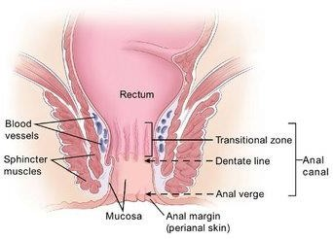

Common Anorectal Disorders:
- Anorectal Abscess
- Anal Fistula
- Anal Fissure
- Hemorrhoids (piles)

Anorectal Abscess:
An anorectal abscess refers to a collection of pus in the anal or rectal region. They are more common in men than in women and have high rates of recurrence.

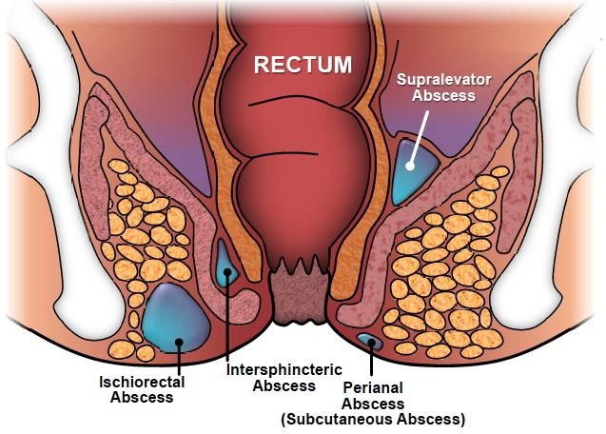

Pathophysiology of anorectal abscess: -
Anorectal abscess is thought to be caused by plugging of the anal ducts, the ducts that drain the anal glands in the anal wall, helping to ease the passage of fecal matter through mucus secretion.
Blockage of an anal duct results in fluid stasis, which will lead to infection.
Common causative organisms include E. coli, and Enterococcus bacteria.
The anal glands are located in the intersphincteric space (between the internal and external anal sphincters), therefore infection from the glands here spreads to adjacent areas.
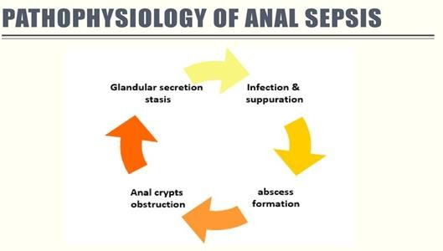

Risk factors:
People with Crohn’s disease or immunosuppressive, conditions such as fistula anal fissure (ulcer), internal or external hemorrhoid.

Clinical Features:
- Pain in the perianal region, which becomes exacerbated when sat down.
- Localized swelling,
- Itching, or discharge
- Severe abscesses may present with systemic features* such as fever, rigors, general malaise, or features of sepsis.

Complications:
  - Fistula
  - Perianal sepsis
  - Necrotizing soft tissue
  - Infection of the anus and surrounding buttock

Management:
- Examination through inspection and digital rectal examination.
- Patients should be started on antibiotic therapy, as guided by local protocol, and provided with sufficient analgesia.
- The main management for anorectal abscesses is with an incision and abscess drainage procedure, which should always be performed under general anesthetic. These can be left to heal by secondary intention.
- Once drained, proctoscopy should be performed to check for the presence of any identifiable fistula.

Nursing care:
- Health education for gentle perineal hygiene and dryness.
- Wear cotton clothes.
- Sitz- baths.

Anal Fistula:
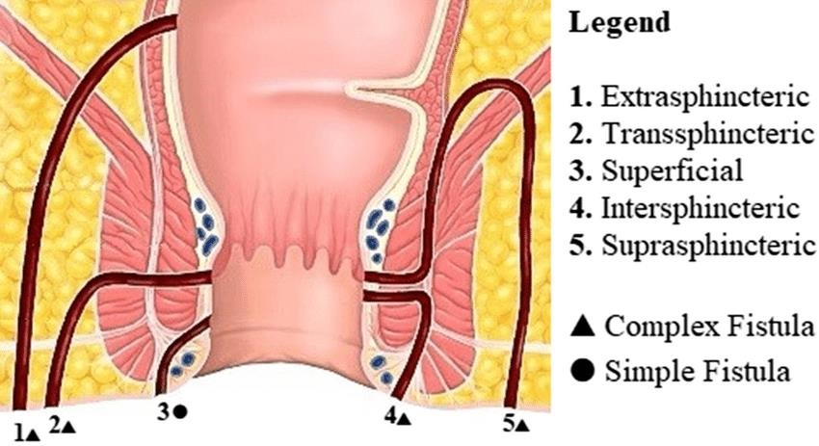An anal fistula is a tiny, tubular, fibrous tract that extends into the anal canal from an opening located beside the anus in the perianal skin.

Risk factors:
- Infection
- Trauma
- Fissures
- Crohn’s disease

Clinical feature: -
- Purulent drainage or stool may leak constantly from the cutaneous opening. Passage of flatus or feces from the vagina or bladder, depending on the location of the fistula tract.

Complications:
- Infection
- Bowel incontinence
- Recurrence of the fistula

Management:
- Diagnosis: through inspection, digital rectal examination, MRI in some cases

- Medical management: Antibiotics or anti-inflammatory type agents (e.g., azathioprine, infliximab, cyclosporine).
- Surgical treatment: because recurrence is common; surgery is recommended because few fistulas heal spontaneously. Surgeries includes mainly: fistulectomy, Seton technique.

Nursing care:
- Frequent observation of the discharge from perineal area.
- Health education for gentle perineal hygiene and dryness.
- Wear cotton clothes.
- Sitz baths.
- Remove the pack as ordered after warm sitz bath gently.
- Avoid strain as in constipation, accumulation of gases…etc.
- Increase fiber and fluid intake.
- Avoid overuse of laxatives.

Anal Fissure:
An anal fissure is a tear in the mucosal lining of the anal canal. It can be classified according to its duration:
Acute – present for < 6 weeks. Chronic – present for > 6 weeks.
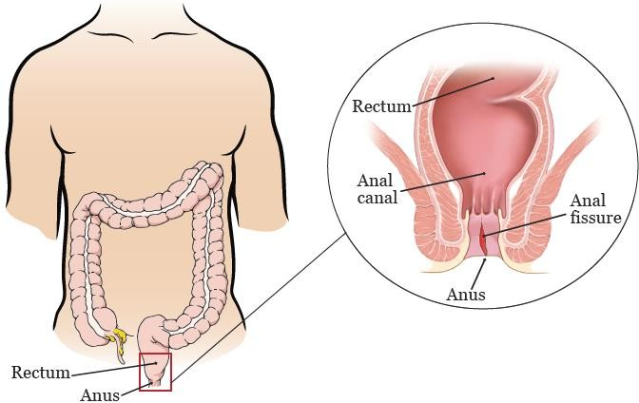

Risk Factor:
- Constipation
- Dehydration
- Inflammatory bowel disease
- Difficult complicated childbirth.
- Trauma.
- Overuse of laxatives which causes the loss of water, minerals, electrolytes (that control muscle contraction) that over dry the indigestible fiber and wastes in the colon.

Clinical Feature:
- Intense pain post-defecation (The most common presenting feature).
- Bleeding (commonly bright red blood on wiping)
- Itching, both typically post-defecation.

Complications:
- Infection of the fissure
- pus formation
- Chronic fissure
- Fistula

Management
- Inspection and no digital rectal examination

Medical Management:
- Dietary modification such as increasing fiber and fluid intake.
- Stool softening laxatives (such as Movicol or Lactulose) can be trialed if there is no change in stool following initial conservative management.
- Topical anesthetics, such as lidocaine,
- Hot baths can help to relax the anal sphincter and also help the healing process.

- If patients are still symptomatic, the next line of management is GTN cream or diltiazem cream. This increases the blood supply to the region and relaxes the internal anal sphincter, putting less pressure on the fissure, promoting healing and reducing pain.

Surgical Management:
Surgical therapy is reserved for chronic fissures where medical management has failed to resolve the symptoms.
A lateral sphincterotomy can be performed.

Nursing care:
- Frequent observation of the discharge from perineal area.
- Health education for gentle perineal hygiene and dryness.
- Wear cotton clothes.
- Sitz baths.
- Remove the pack as ordered after warm sitz bath gently.
- Avoid strain as in constipation, accumulation of gases…etc.
- Increase fiber and fluid intake.
- Avoid overuse of laxatives.

Hemorrhoids (piles):
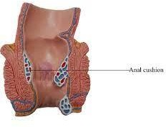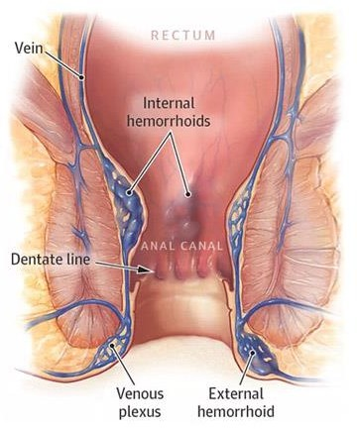Abnormal swelling or enlargement of the anal vascular cushions. The anal vascular cushions act to assist the anal sphincter in maintaining continence. There are three vascular cushions in the anus.

Hemorrhoids are classified to:
-Internal hemorrhoids: hemorrhoids located above the internal sphincter.
-External hemorrhoids: hemorrhoids located outside the external sphincter. External hemorrhoids are also classified by degree of prolapse into:

Classification | Description
1st Degree | Remain in the rectum.
2nd Degree | Prolapse through the anus on defecation but spontaneously reduce.
3rd Degree | Prolapse through the anus on defecation but require digital reduction.
4th Degree | Remain persistently prolapsed.

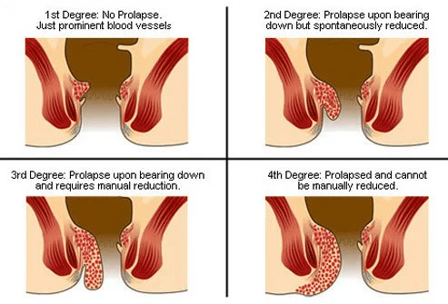

Risk Factors:
- Excessive straining (from chronic constipation),
- Increasing age,
- Raised intra-abdominal pressure (such as pregnancy, chronic cough, or ascites).
- Other less common risk factors include (pelvic or abdominal masses, family history).

Clinical Feature: -
- Painless bright red rectal bleeding, commonly after defecation Importantly, blood is seen on the surface of the stool, not mixed in.
- Pruritus (due to chronic mucus discharge and irritation),
- Rectal fullness or an anal lump.
- Large prolapsed hemorrhoids can thrombose. These are very painful and these patients frequently present acutely as an emergency patient.

Complication:
- Anemia.
- Blood clots in external hemorrhoids.
- Infection.
- Strangulated hemorrhoids (muscles in the anus cut off blood flow to a prolapsed hemorrhoid).

Medical management:
Diagnosis through inspection, digital rectal examination, proctoscopy, or sigmoidoscopy.
Nonsurgical treatment to attach the mucosa to the underlying muscle to prevent hemorrhoids prolapse:
- Infrared photocoagulation.
- Bipolar diathermy.
- Laser therapy
- Injection of sclerosing agents is also effective for small, bleeding hemorrhoids.

Surgical treatment:
- Rubber-band ligation.
- Cryosurgical hemorrhoidectomy.
- Stapled hemorrhoidopexy/ or Hemorrhoidectomy.

Nursing care: -
- Gentle perineal hygiene and dryness.
- Avoid excessive straining during defecation.
- A high-residue bulk-forming diet that contains fruit and bran.
- Increased fluid intake.
- Avoid constipation.
- Warm compresses and sitz baths.
- Analgesic ointments and suppositories, astringents (cause shrinking of the piles).
- Encourage bed rest.

General education of patients with anorectal condition:
- Patient education is essential to facilitate recovery at home.
- The nurse instructs the patient to keep the perianal area as clean as possible by gently cleansing with warm water and then drying with absorbent cotton wipes.
- The patient should avoid rubbing the area with toilet tissue.
- Instructions are provided about how to take a sitz bath and how to test the temperature of the water.
- During the first 24 hours after rectal surgery, painful spasms of the sphincter and perineal muscles may occur.
- The nurse instructs the patient that ice and analgesic ointments may decrease the pain. Warm compresses may promote circulation and soothe irritated tissues.
- Sitz baths taken 3 to 4 times each day can relieve soreness and pain by relaxing sphincter spasm.
- Twenty-four hours after surgery, topical anesthetic agents may be beneficial in relieving local irritation and soreness.

- Medications may include topical anesthetics (i.e., suppositories), astringents, antiseptics, tranquilizers, and antiemetic agents.
- Patients are more adherent and less apprehensive if they are free of pain. 11.Wet dressings saturated with equal parts of cold water and witch hazel help
relieve edema.
- When wet compresses are being used continuously, petrolatum is applied around the anal area to prevent skin maceration.
- The patient is instructed to assume a prone position at intervals because this position reduces edema of the tissue.

Common nursing diagnosis with anorectal disorders:

Constipation (relative) related to
Ignore the urge to defecate due to pain /or Fear from pain.

As evidenced by patient report that
Doesn't pass stool since……days/ Passage of hard, formed stool/or Abdominal distention/ or A feeling of rectal fullness.

Nursing goal: (patient will be)
normal elimination pattern reestablished and maintained.

Pain(acute/ chronic) related to
Rectal swelling or spasm/ or inflammation and edema of prolapsed varices.

As evidenced by
Verbalization of pain/ or fascial expression.

Nursing goal: (patient will be):
Patient will report pain is decreased.
- Alteration in Comfort related to
presence of pain and distress secondary to hemorrhoids

as evidenced by

verbalization of exhaustion, rapid breathing, irritability, and restlessness.

Nursing goal: (patient will be)
report improvement in pain and discomfort brought by hemorrhoids.
be knowledgeable about different comfort measures to relieve hemorrhoid pain.

